**Technological Institute of the Philippines**

938 Aurora Blvd., Cubao, Quezon City

4 Way Traffic Light Using Assembly Language

Cabrera, Jerome Arvin A.

Cabug-os, Mark Jetro M.

Calura, Ricardo R.

Chua, Royce B.

Cubar, Jose Mari C.

Engr. Jonathan V. Taylar

**Instructor**

Table of Contents

**Chapter 1**

Background1

Technology1

Innovation2

General Objectives2

Specific Objectives2

**Chapter 2**

Project Design3

Description3

Hardware Design**3**

Software Design4

Illustrations5

**Chapter 3**

Final Design7

Final Design Picture9

Assembly Codes10

Evidence of Group Work13

Members Information15

**Chapter 1 – The Project and Its Background**

**Background**

A four-way traffic light is a device that is located at the road intersection to control the flow of traffic and avoid any accidents within the intersection. It is the most effective tool for sequential control of the teaming number of vehicles on the road and help the pedestrians cross the road safely.

Traffic light nowadays are commonly used in city and can also be used in universities, malls, airports or any road that has intersection. It also helps keeps order on the road as it prevents congestion on some parts of the road by delaying the number of cars that pass through.

**Technology**

The legacy Four-way traffic light is made of a logic circuit with the help of counter IC, which is mainly used for Sequential Circuits. We can also call it as Sequential Traffic Lights. Sequential Circuits are used to count the numbers in the series. Coming to the working principle of Traffic Lights, the main IC is 4017 counter IC which is used to glow the Red, yellow and green LED respectively. 555 timer acts as a pulse generator providing an input to the 4017 counter IC. Timing of glow of certain lights totally depends upon the 555 timer’s pulse, which we can control via the Potentiometer so if you want to change the time of glow, you can do so by varying the potentiometer, having the responsibility for the timing.

**Innovation**

The modern technologies available for the traffic light system is a programmable one using microprocessors and a programming language compatible with the processor’s specification. This project will use the x86 processor that can be found commonly in desktop PCs running Windows. This approach will not only reduce the number of circuits that needs to be used and replaced but also make the system easier to reprogram and change the parameters such as delay which would be difficult with the combinational logic circuit approach. This approach needs only for the user to wire output pins to the LEDs and most of the logic is implemented through the program code.

**General Objective**

To create a complete 4-Way Traffic Light System with LEDs using Assembly language.

**Specific Objective**

* To use TASM in writing the Assembly Code
* To control LEDs using the computer’s parallel port
* To provide a timed sequence of LED lighting
* To maintain synchronization between the two traffic light’s LED values

**Chapter 2 - Project Design**

**Description**

The project is a 4 Way Traffic Light System composed of two synchronized traffic lights being controlled by a computer using the Assembly Language. The Assembly Language uses the parallel port or printer port of the computer to send controlled digital signals to the traffic light.

**Hardware Design**



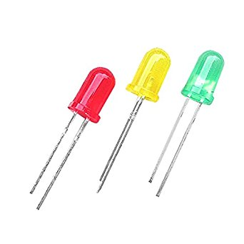

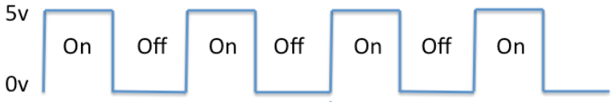

Figure 2.1 Shows the hardware components to be used and how they interact with one another

The hardware design is composed of: a system unit with a parallel port which acts the I/O port for this project, and the traffic light composed of the LEDs and resistors. The system unit sends a controlled voltage pulse between 5V or 0V which then turns the LEDs on or off. LEDs can be wired directly from the parallel port of the system unit therefore no Printed circuit board is included in the hardware design.

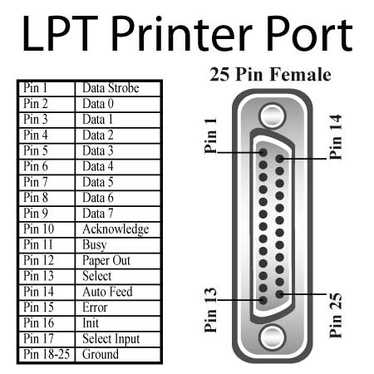

Figure 2. 2 The parallel port and its pin outputs

The parallel port or LPT printer port serves as the I/O Port of the computer from which electronic components can be controlled using digital signals which can be triggered by the program.

**Software Design**

The software design was the most crucial part of the project that determined the LED lighting sequence as well as the time delay in seconds to model an actual traffic light. The software was written using Assembly Language and the Turbo Assembler as the computer assembler (software for program development) that was developed by Borland which runs on and produces code for 16- or 32-bit x86 MS-DOS or Microsoft Windows. Assembly language was used because accessing hardware is more convenient and required less lines of code to control the output or data pins of the parallel port. Also, Assembly Language is more memory efficient therefore this device can run seamlessly without consuming as much memory as common software would.

The flow of the system can easily be understood through the outline of the program’s algorithm. The first assumption is that one traffic light would be green, and the other traffic light would be off and that would be the starting point of the program along with the consideration of important parameters given for the project such as the delay of LED lights.

Access parallel port address

Set green led of T1 to high and the red led of T2 to high.

Delay for 10 seconds

Set green led of T1 low, and yellow led of T1 high

Delay for 2 seconds

Set yellow led of T1 low, and red led of T1 high

Set red led of T2 low, and green led of T2 high

Delay for 10 seconds

Set green led of T2 low, and yellow led of T2 high

Delay for 2 seconds

Set yellow led of T2 low

Repeat the entire process indefinitely

Synchronization needs to be maintained between the two-traffic light to maintain traffic management efficiency and safety. Implementing the algorithm above in assembly language will result in the project.